Wander State Website

Strategic Summary
This Strategic Summary forms the foundation for content development, design, and the wireframe/digital build.

Brand Narrative & Positioning
• Wander State is a premium, nature-inspired wellness beverage brand rooted in curiosity, exploration, connection, and intentional living.
• The voice is warm, grounded, curious, and lightly poetic but never vague.
• The visual direction combines Nature Organic × Premium Wellness.

Home Page
Home Page: lean in on product/brand promise/lifestyle. The overarching north star here is: Stay Curious. Explore. Connect. We also need to incorporate our tagline prominently: Nourish Your Journey. We want imagery and video of PNW nature, active and fun lifestyle. Need to highlight our product and science here as well.
Homepage Strategy
• Lead with emotion, then introduce the product.
• Hero: cinematic nature backdrop, headline “Stay Curious. Explore. Connect.”
• Supporting copy: “A sparkling tea designed to nourish your journey.”
• Flow:
- Hero
- Tagline block (“Nourish Your Journey”)
- Beverage teaser (4 SKUs)
- Daypart selector (morning, evening, movement, social)
- Mushroom science preview
- Clinical evidence preview
- Friends & partners preview
- Community CTA (“Where We Wander”)
- Footer with compliance

Beverages Page
Beverages Page: Headline should showcase drinkability and wellness, including crisp, light, effervescent, low calorie, no added sugar, real tea, full spectrum functional mushrooms. Showcase all of our can mockups and incorporate imagery showcasing dayparts:
Lemon & Mint: person on a bench next to a lake watching the sun rise
Chamomile & Blackberry: person in bed reading a book
Yuzu & Cucumber: person running in a forest
Hibiscus & Blood Orange: People having a fucking blast at a party
Beverages Page Strategy
• Flavor-first approach: tasting notes, sensory description.
• Clean 4-card grid.
• Daypart scroller.
• Ingredient transparency block.
• Clear CTA “Shop All Beverages.”

Individual SKU Page Strategy
Individual SKU Page Strategy (Product-First Layout)
• Large product render left, copy right.
• Modules:
- Hero (can image + flavor notes)
- Functionality (Lion’s Mane, Reishi, Cordyceps)
- Ingredient panel
- “The Experience” block
- Daypart usage
- Nutrition facts
- Accordion for ingredients, sourcing, FAQ
• Consistent, conversion-oriented but still premium.

Friends & Partners Page
Friends & Partners Page: Showcase Monterey Nutra as our mushroom source, Forest Farmers, Washington Trails Association to humanize our brand and reinforce our claims and authenticity. Specifically highlight our friendship with Amir Karian at Monterey Nutra and Mike Farrell from Forest Farmers
Friends & Partners Page Strategy
• Highlight: Monterey Nutra (Amir Karian), Forest Farmers (Mike Farrell), Washington Trails Association.
• Add human photos and short micro-stories.
• Structure:
- Hero
- Partner cards
- Stories & contribution
- Values & shared mission

Merch Page
Merch Page: Leave blank for now

Mushroom Science Page
Mushroom Science Page: Take the info from these links to use for content:
- https://www.montereynutra.com/frequently-asked-questions
- https://www.montereynutra.com/products#extracts
- https://www.montereynutra.com/products#fruiting-body
- https://www.montereynutra.com/products#full-spectrum-powder
- https://www.montereynutra.com/species - we are using lion’s mane, reishi, and cordyceps
Mushroom Science Page Strategy
• Clear explanation of why mushrooms.
• Meet the Mushrooms (Lion’s Mane, Reishi, Cordyceps).
• Full-spectrum sourcing philosophy.
• Clinical evidence table (lion’s mane cognitive trials, reishi fatigue trials, cordyceps endurance trials). See clinical studies data below.
• Links to COAs + sourcing partners.
• Tone: clear, transparent, consumer-friendly.

Where We Wander Page
Where We Wander Page
Include a link to Washington Trails Association
Add geo-tag functionality so customers can tag their journeys – hikes, travel, etc.
Where We Wander Page Strategy
• Community-driven.
• Map module with user-submitted wander points.
• Encourage tagging hikes, trails, journeys.
• CTA: “Add Your Wander.”
• Social integration: IG hashtag system.

About Us Page
About Us Page: See content below (NEED ERIC TO INCLUDE SOMETHING FOR HIMSELF)
About Us Page Strategy
• Story-first layout.
• Highlight Tommy’s and Eric’s journeys.
• Include imagery (non-corporate).
• Essence:
“A beverage company rooted in connection.”
• Break content into:
- How it started
- Personal journeys
- Shared values
- Founders’ vision

Stay Connected Page
Stay Connected Page: This is to sign up for our newsletter, product alerts, events, etc.

Where To Find Us Page
Where To Find Us Page - showcase Sprouts

Blog Page
Blog Page – leave blank for now

Navigation Structure
Primary Nav:
• Beverages
• Merch
• Where We Wander
• Mushroom Science
• About Us
• Friends & Partners
Utility:
• Shop CTA (right aligned)
Footer:
• Where to Find Us
• Stay Connected
• Blog
• Compliance
• Social links

Tone & Voice Summary
Tone & Voice Summary
• Warm, intentional, grounded, connected.
• Nature-infused but modern.
• Confident without being clinical.
• Functional but approachable.
• Emotion-first, evidence-supported.

Product Line Details
Product Line Details
Lemon & Mint Sparkling Green Tea
🚀 Purpose: A crisp, citrus-forward morning tea designed to enhance mental clarity and endurance with a clean energy boost.
Ideal Daypart/Need State: Morning
Flavor Profile: Bright lemon, smooth green tea, cooling mint.
Ingredients:
Green Tea
Lemon
Mint
Maple Water
Lion’s Mane Mushrooms
Cordyceps Mushrooms
Chamomile & Blackberry Sparkling Tea
🌙 Purpose: A soothing, floral sparkling tea designed for relaxation and stress relief.
Ideal Daypart/Need State: Evening / Relaxing
Flavor Profile: Soft chamomile, tart blackberry. Warming cinnamon spice
Ingredients:
Chamomile Tea
Blackberry
Cinnamon
Maple Water
Lion’s Mane Mushrooms
Reishi Mushrooms
Yuzu & Cucumber Sparkling Black Tea
💪 Purpose: Refreshing, hydrating, and endurance-boosting tea with natural energy support.
Flavor Profile: Bright yuzu citrus, crisp cucumber, smooth black tea, balanced by pink Himalayan sea salt
Ideal Daypart/Need State: Morning / Pre & Post Exercise
Ingredients:
Black Tea
Yuzu
Cucumber
Himalayan Pink Sea Salt
Maple Water
Lion’s Mane Mushrooms
Cordyceps Mushrooms
Hibiscus & Blood Orange Sparkling Tea
🥂 Purpose: A festive, alcohol-free sparkling tea inspired by the iconic Italian Spritz. This blend delivers a bitter-sweet complexity and vibrant citrus character — a true non-alcoholic aperitif experience.
Flavor Profile: Italian Aperitif, tart hibiscus, bright blood orange, herbal, bitter orange peel, floral elderflower
Ideal Daypart/Need State: Afternoon/Evening - Perfect N/A option for a party or celebration.
Ingredients:
Hibiscus
Blood Orange
Elderflower
Orange Peel
Maple Water
Lion’s Mane Mushrooms
Reishi Mushrooms

Our Story:
Wander State: Who We Are / Our Story
Wander State began in Seattle in 2014, rooted in a friendship built on shared values, mutual respect, and a desire to create something meaningful. At the time, Tommy was leading operations and reimagining the beverage program at a local pizza chain, while Eric was at the helm of Jones Soda. When the two partnered to replace Coke with Jones as the chain’s local soda partner, it was a small but telling move—it confirmed they saw brand, business, and relationships through the same lens.
As the years passed, the idea of building something together kept resurfacing. Eventually, life lined up. Over a beer at a neighborhood brewery, Tommy pitched Eric on starting a beverage company—one centered around functional mushrooms.
About Tommy
Tommy brings over a decade of leadership in the food and beverage industry, where he built and scaled beverage programs for multi-unit restaurant groups and cultivated deep relationships with brands, distributors, and operators. His background blends operational expertise with sharp consumer insight—particularly into the evolving demand for wellness-driven, functional beverages.
That professional path runs parallel to a personal one. During a difficult period, Tommy began exploring functional mushrooms as a tool for mental clarity, physical performance, and emotional grounding. They worked—and quickly became essential to his wellness routine. That lived experience, paired with years of experience designing what ends up on menus and shelves, revealed a clear white space: today’s consumers want more from what they drink. They want clean, purposeful ingredients. Products that deliver tangible benefit. And they want to feel connected—to what they’re putting in their bodies and the world around them.
Tommy’s passion for health, nature, and human connection is deeply embedded in Wander State’s mission. Raised in California’s Bay Area, he was early to wellness—prioritizing whole foods and environmental activism long before either were mainstream. A lifelong athlete, he now competes in trail races as a sponsored runner for the Seattle Brooks Running Club, and continues to spend as much time in nature as possible.
To Tommy, nature is medicine. And connection—to self, to others, and to the planet—is at the heart of what it means to be well.
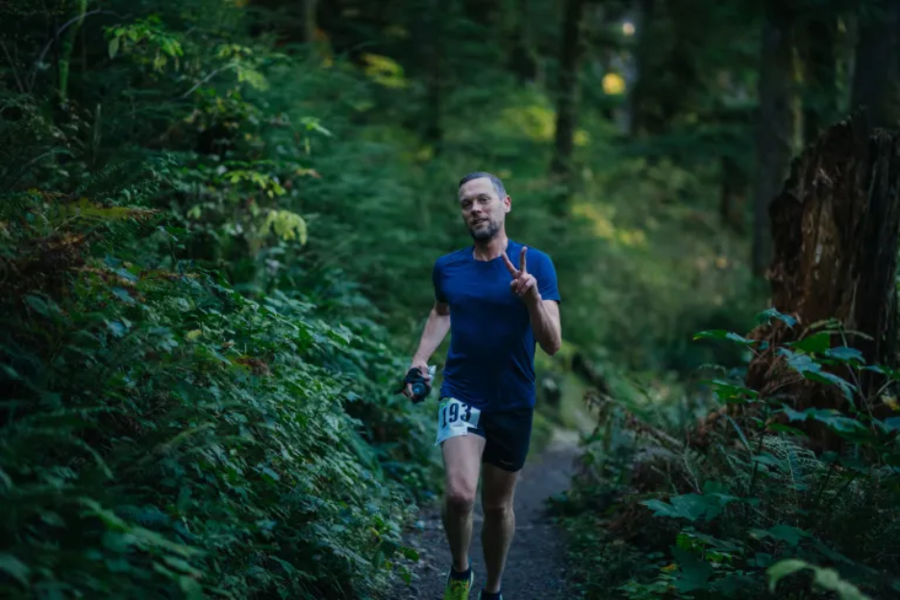
INSERT ERIC’S STORY HERE
(Once added, this should echo Tommy’s personal/professional synergy and emphasize complementary experience.)
While functional mushroom beverages existed, they felt limited—often clinical, inaccessible, or uninspired. We envisioned something more: a product that was approachable, intentional, and effective. Easy to grab for specific dayparts or activities. Rooted in functionality, but designed to spark curiosity, invite connection, and act as a gateway to nature and community.
From day one, Wander State has been about connection—to ourselves, each other, and nature. This journey has deepened our relationships with our families, friends, and partners. Our hope is that it helps others feel more connected too.
Wherever your path takes you, we’re grateful to wander with you.

Clinical Studies Content: Markdown and HTML code included below if helpful
Markdown Code
## Clinical Evidence Summary
Functional Mushrooms Used: **Lion’s Mane**, **Reishi**, **Cordyceps**
Below are the most respected, legitimate, and well-validated human clinical trials for the mushrooms used in our formulas.
---
### 🧠 Lion’s Mane (Hericium erinaceus)
| Study | Population & Outcome | Key Details | Link | Suggested Copy |
|-------|----------------------|-------------|------|----------------|
| **Mori et al., 2009 — 16-week Double-Blind RCT** | Older adults (50–80) with mild cognitive impairment | 16-week randomized, double-blind placebo-controlled trial. Lion’s Mane improved cognitive test scores; effects diminished after stopping supplementation. | PDF: https://www.mushroomcouncil.com/wp-content/uploads/2023/08/Phytotherapy-Research-2008-Mori-Improving-effects-of-the-mushroom-Yamabushitake-Hericium-erinaceus-on-mild-3.pdf | *“In a 16-week double-blind, placebo-controlled trial, Lion’s Mane significantly improved cognitive scores in older adults with mild cognitive impairment.”* |
| **Saitsu et al., 2019 — 12-week Double-Blind RCT** | Healthy middle-aged/older adults | Randomized, double-blind placebo-controlled trial; Lion’s Mane improved cognitive performance in several domains vs placebo. | PDF: https://www.jstage.jst.go.jp/article/biomedres/40/4/40_125/_pdf | *“In a 12-week randomized, placebo-controlled study, Lion’s Mane improved cognitive performance in healthy adults.”* |
---
### 🛡️ Reishi (Ganoderma lucidum)
| Study | Population & Outcome | Key Details | Link | Suggested Copy |
|-------|----------------------|-------------|------|----------------|
| **Tang et al., 2005 — Double-Blind RCT on Neurasthenia** | Adults with neurasthenia (fatigue/weakness syndrome) | Randomized, double-blind placebo-controlled trial of Ganopoly® (standardized Reishi polysaccharide extract). Improved fatigue-related symptoms and well-being vs placebo. | Abstract: https://europepmc.org/abstract/MED/15857210 | *“In a randomized, double-blind, placebo-controlled trial, a standardized Reishi extract improved fatigue-related symptoms and well-being.”* |
---
### ⚡ Cordyceps (C. sinensis / C. militaris)
| Study | Population & Outcome | Key Details | Link | Suggested Copy |
|-------|----------------------|-------------|------|----------------|
| **Savioli et al., 2022 — 12-week Double-Blind RCT** | Amateur marathoners | 12-week randomized, double-blind placebo-controlled trial (2 g/day Cordyceps sinensis). Improved aerobic performance vs placebo. | Article: https://www.sciencedirect.com/science/article/abs/pii/S2210803322000392 | *“In a 12-week double-blind trial with amateur marathoners, Cordyceps improved aerobic performance compared with placebo.”* |
---
### ⚠️ Disclaimer
*Human trials are promising but generally small and conducted in specific populations. Results may not apply to everyone.*
HTML Code:
<section>
<h2>Clinical Evidence Summary</h2>
<p><strong>Functional Mushrooms Used:</strong> Lion’s Mane, Reishi, Cordyceps</p>
<p>Below are the most respected, legitimate, and well-validated human clinical trials for the mushrooms used in our formulas.</p>
<hr>
<h3>🧠 Lion’s Mane (Hericium erinaceus)</h3>
<table>
<thead>
<tr>
<th>Study</th>
<th>Population &amp; Outcome</th>
<th>Key Details</th>
<th>Link</th>
<th>Suggested Copy</th>
</tr>
</thead>
<tbody>
<tr>
<td><strong>Mori et al., 2009 — 16-week Double-Blind RCT</strong></td>
<td>Older adults (50–80) with mild cognitive impairment</td>
<td>16-week randomized, double-blind, placebo-controlled trial. Lion’s Mane improved cognitive test scores; effects diminished after stopping supplementation.</td>
<td><a href="https://www.mushroomcouncil.com/wp-content/uploads/2023/08/Phytotherapy-Research-2008-Mori-Improving-effects-of-the-mushroom-Yamabushitake-Hericium-erinaceus-on-mild-3.pdf" target="_blank">Study PDF</a></td>
<td><em>“In a 16-week double-blind, placebo-controlled trial, Lion’s Mane significantly improved cognitive scores in older adults with mild cognitive impairment.”</em></td>
</tr>
<tr>
<td><strong>Saitsu et al., 2019 — 12-week Double-Blind RCT</strong></td>
<td>Healthy middle-aged/older adults</td>
<td>Randomized, double-blind, placebo-controlled trial; Lion’s Mane improved cognitive performance in several domains vs placebo.</td>
<td><a href="https://www.jstage.jst.go.jp/article/biomedres/40/4/40_125/_pdf" target="_blank">Study PDF</a></td>
<td><em>“In a 12-week randomized, placebo-controlled study, Lion’s Mane improved cognitive performance in healthy adults.”</em></td>
</tr>
</tbody>
</table>
<hr>
<h3>🛡️ Reishi (Ganoderma lucidum)</h3>
<table>
<thead>
<tr>
<th>Study</th>
<th>Population &amp; Outcome</th>
<th>Key Details</th>
<th>Link</th>
<th>Suggested Copy</th>
</tr>
</thead>
<tbody>
<tr>
<td><strong>Tang et al., 2005 — Double-Blind RCT</strong></td>
<td>Adults with neurasthenia (fatigue/weakness syndrome)</td>
<td>Randomized, double-blind, placebo-controlled trial of Ganopoly® (standardized Reishi polysaccharide extract). Improved fatigue-related symptoms and well-being vs placebo.</td>
<td><a href="https://europepmc.org/abstract/MED/15857210" target="_blank">Study Abstract</a></td>
<td><em>“In a randomized, double-blind, placebo-controlled trial, a standardized Reishi extract improved fatigue-related symptoms and well-being.”</em></td>
</tr>
</tbody>
</table>
<hr>
<h3>⚡ Cordyceps (C. sinensis / C. militaris)</h3>
<table>
<thead>
<tr>
<th>Study</th>
<th>Population &amp; Outcome</th>
<th>Key Details</th>
<th>Link</th>
<th>Suggested Copy</th>
</tr>
</thead>
<tbody>
<tr>
<td><strong>Savioli et al., 2022 — 12-week Double-Blind RCT</strong></td>
<td>Amateur marathoners</td>
<td>12-week randomized, double-blind, placebo-controlled trial (2 g/day Cordyceps sinensis). Improved aerobic performance vs placebo.</td>
<td><a href="https://www.sciencedirect.com/science/article/abs/pii/S2210803322000392" target="_blank">Study Article</a></td>
<td><em>“In a 12-week double-blind trial with amateur marathoners, Cordyceps improved aerobic performance compared with placebo.”</em></td>
</tr>
</tbody>
</table>
<hr>
<p><strong>Disclaimer:</strong> Human trials are promising but generally small and conducted in specific populations. Results may not apply to everyone.</p>
</section>

